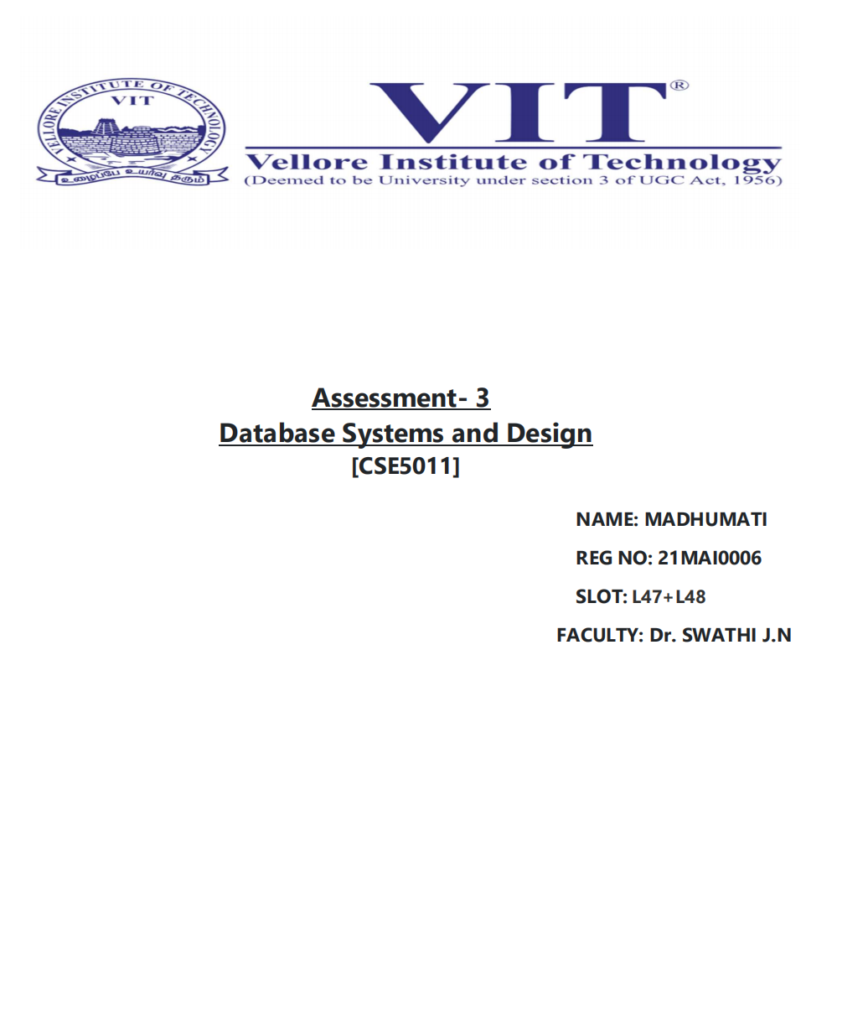

**NAME: KAUSHAL BAGHEL**

**ROLL NO: 21MAI0003**

**SLOT :L47+L48**

**FACULTY : Dr. SWATHI J.N.**

**EXERCISE 5**

**SUBQUERY AND VIEW**

**Aim: to understand the concept of Sub queries and logical tables in oracle.**

1. Find the employee who is getting highest salary in the department research

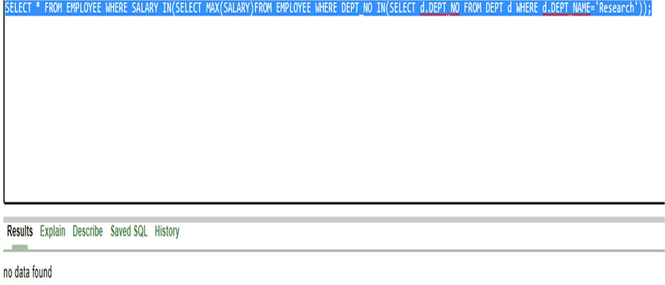

1. Find the employees who earn the same salary as the minimum salary for each Department

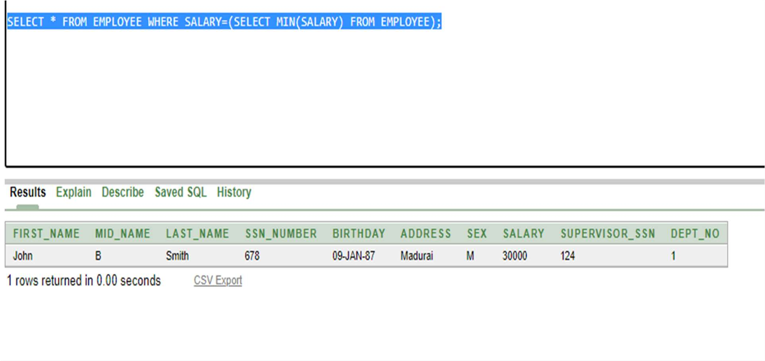

3.Find the employee whose salary is greater than average salary of department 2

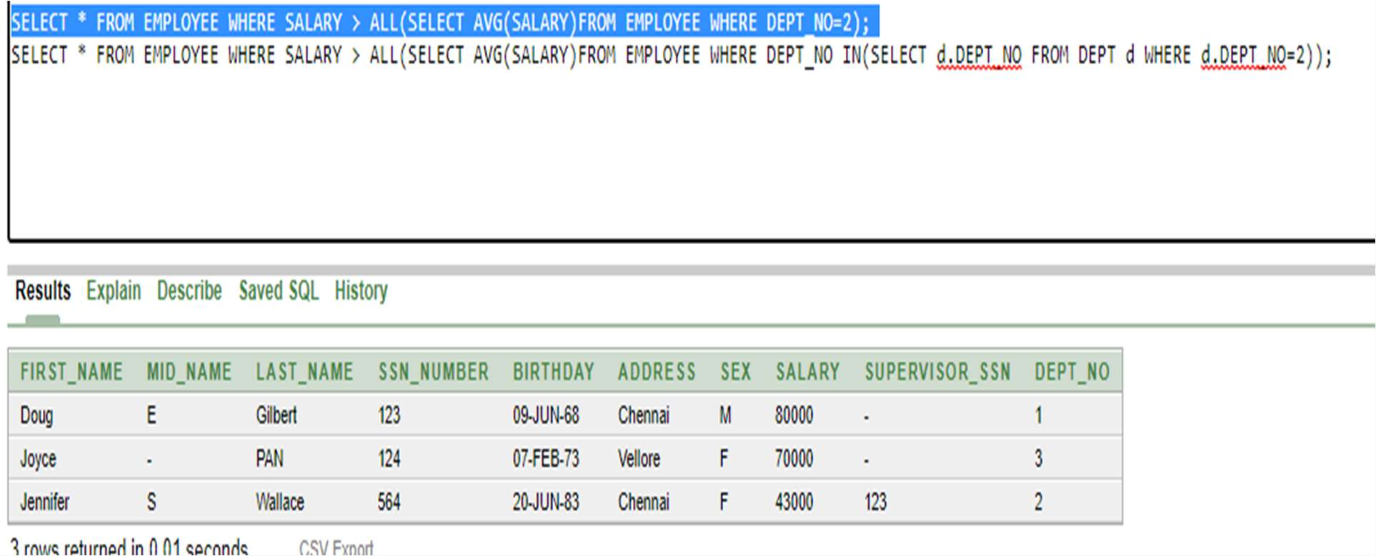

4.List out all the department names with their individual employees strength

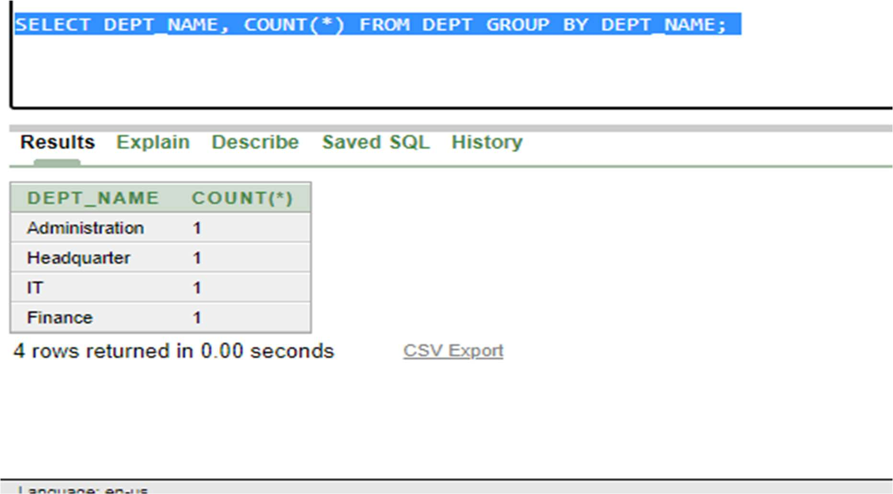

1. Find out the department name having highest employee strength

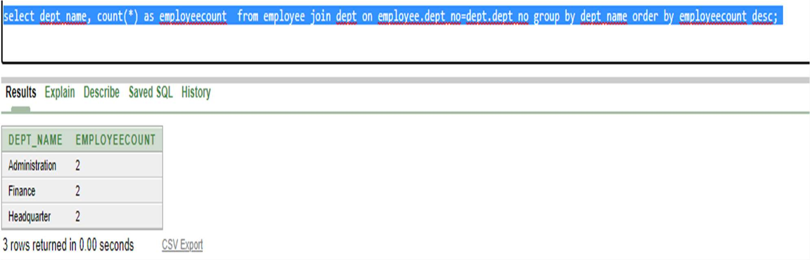

1. List out all the departments and average salary drawn by their employees

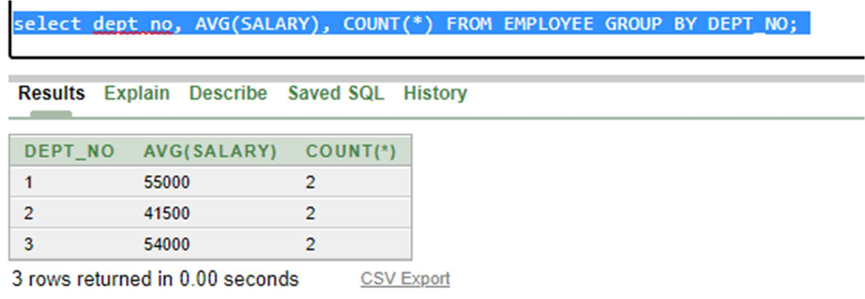

1. Find maximum average salary for each department.

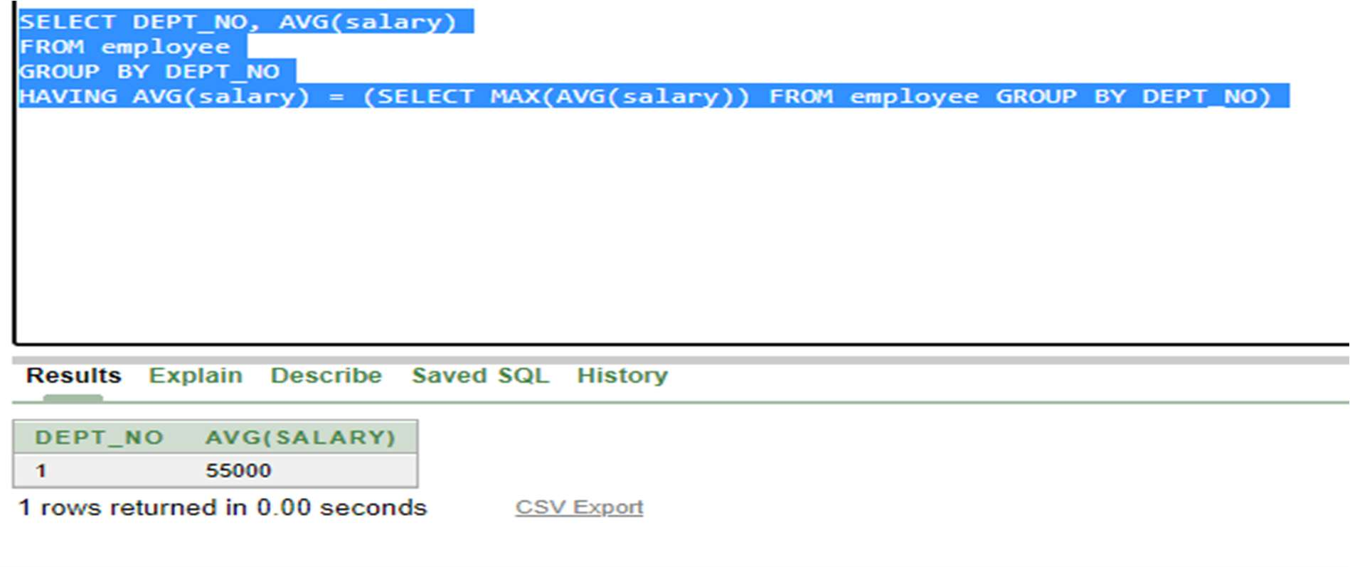

1. Create a view to display the employee details who is working in IT department.\

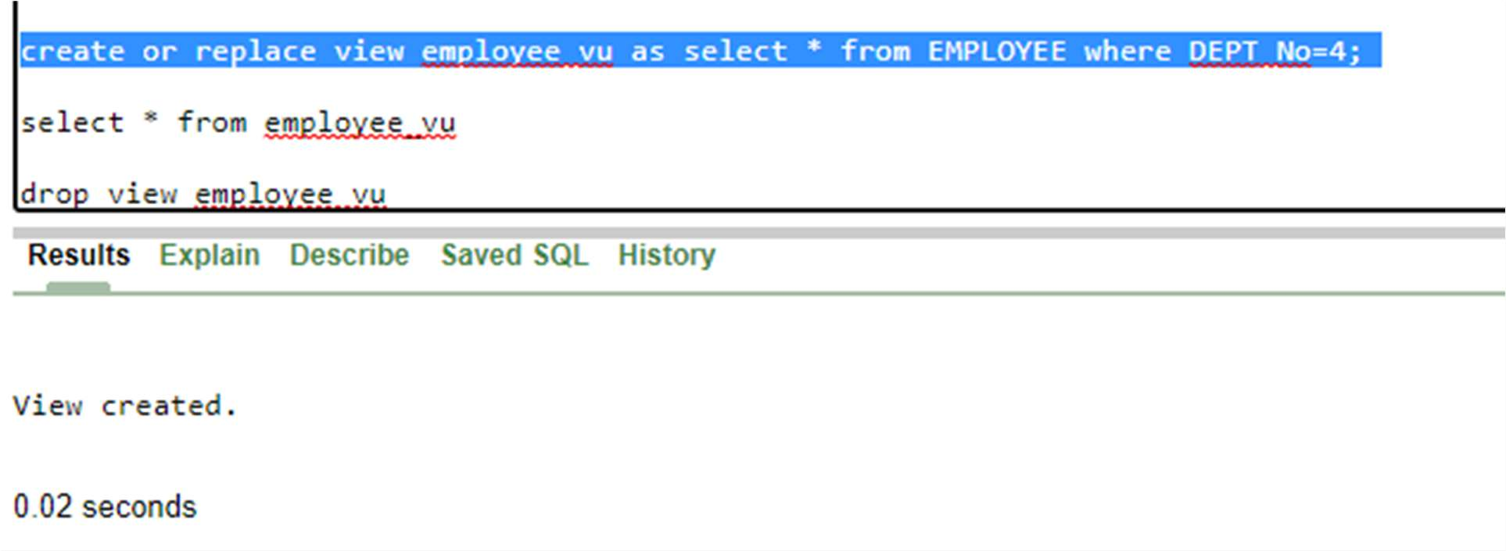

9.Create a logical table to store employee details who is getting salary more than

10000.

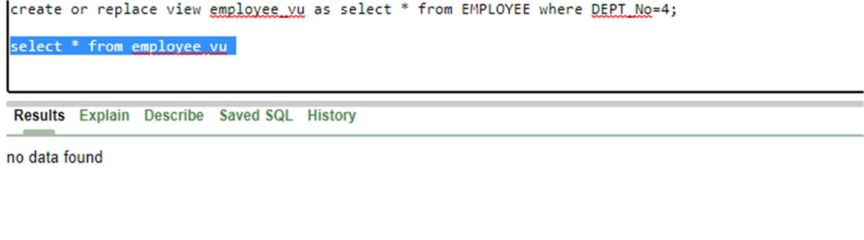

10.Create a table to store the employees details based on the dep

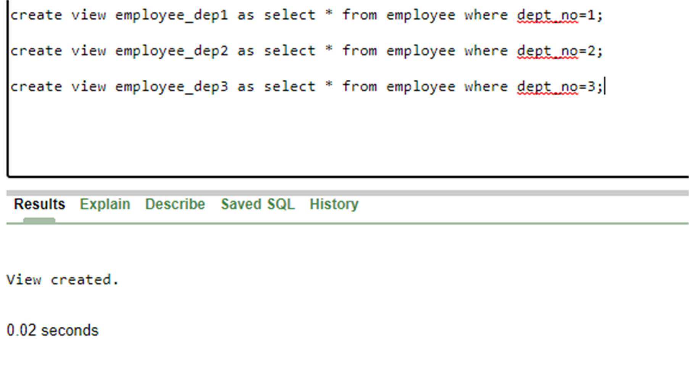

**Exercise: VI**

**Joins**

**Aim: To understand how to relate and access data from multiple tables.**

1. Retrieve the names of all employees in department 5 who work more than 10 hours per week on ProductX project. 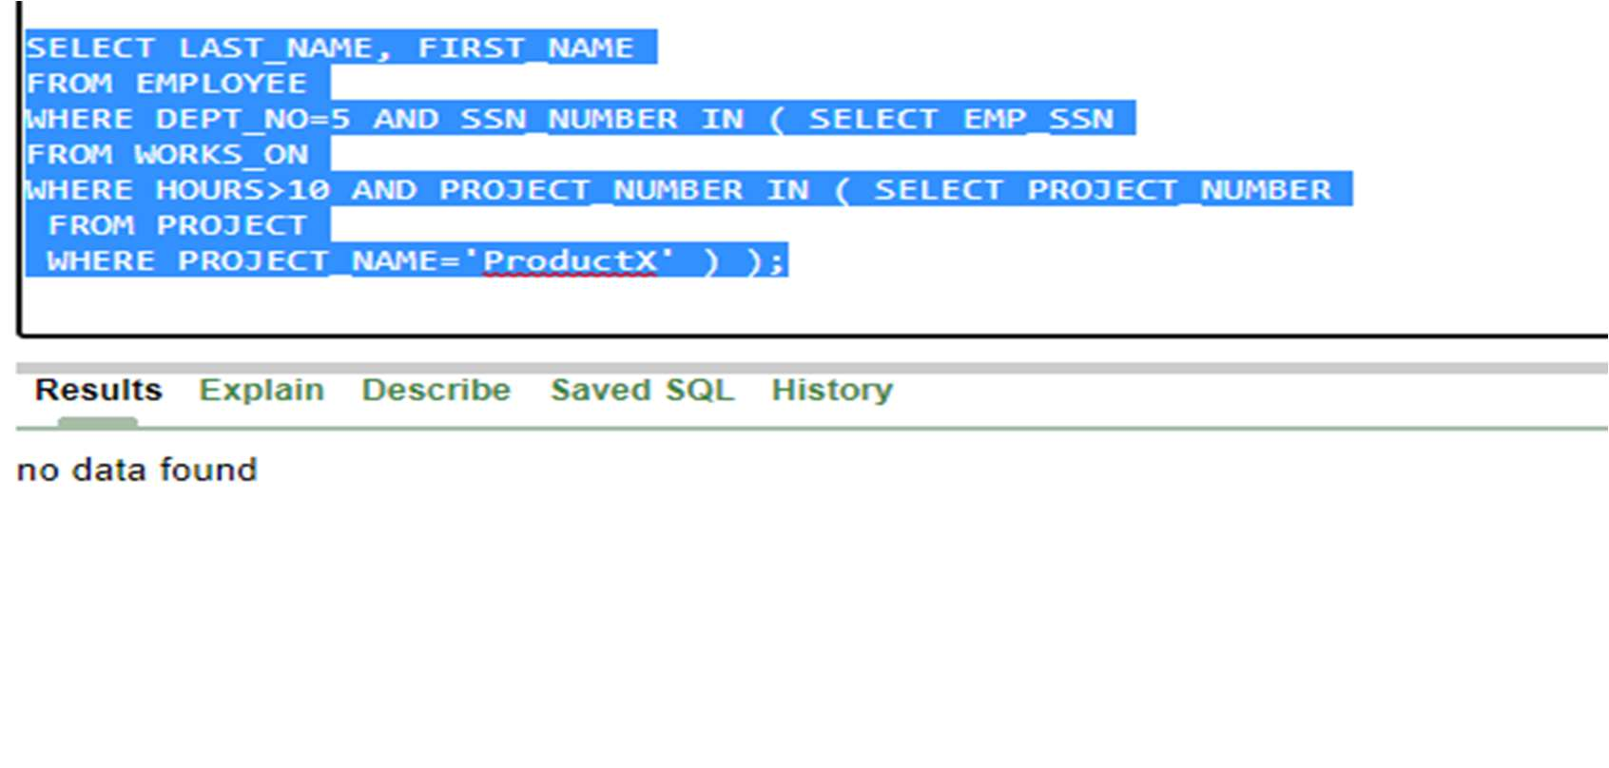
2. List the names of all employees who have a dependent with the same first name as themselves.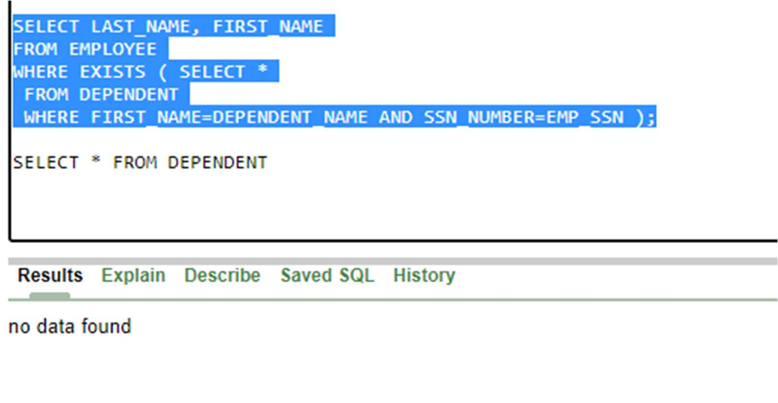
3. Find the names of all the employees who are directly supervised by ‘Franklin Wong’. 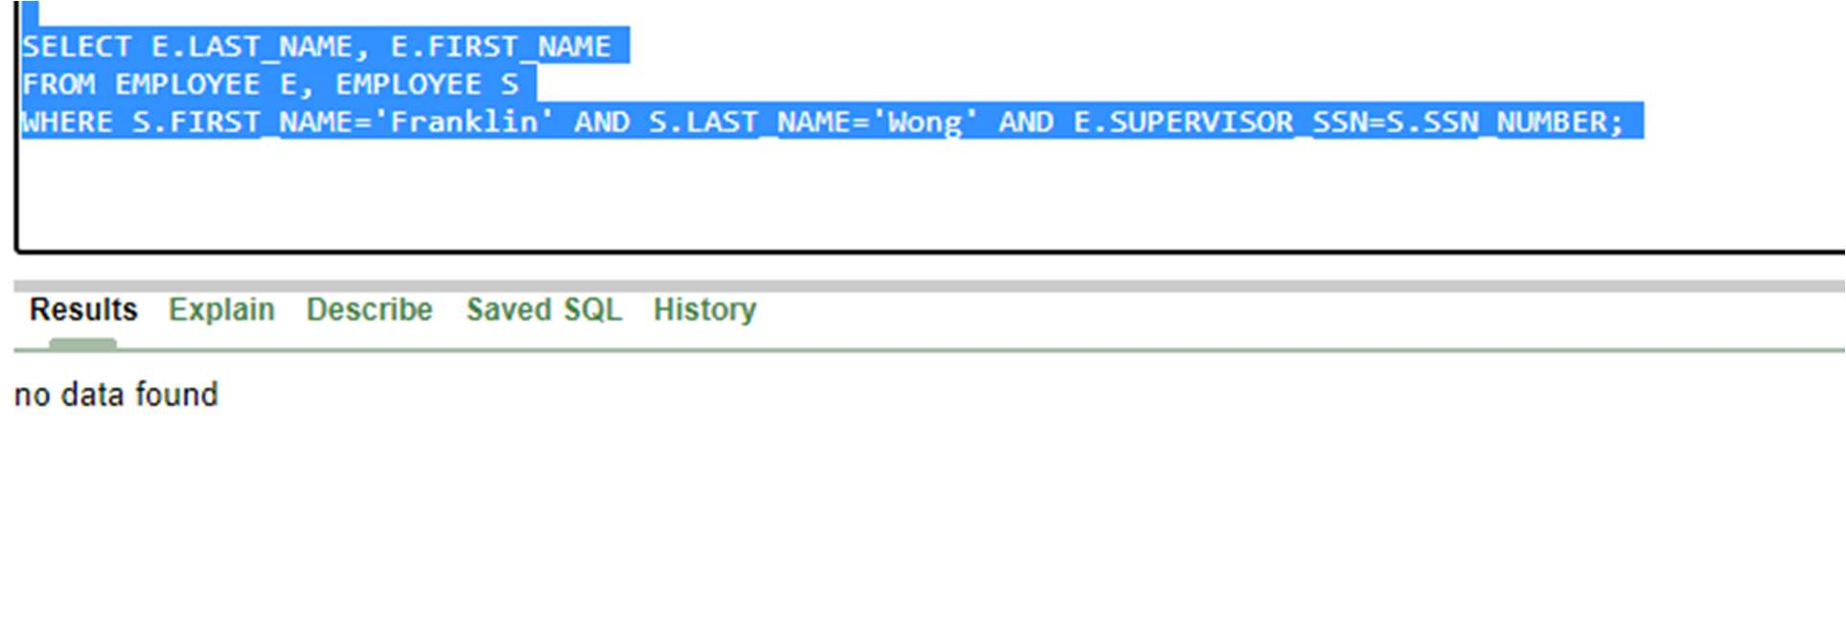
4. Retrieve the names of all who do not work on any project.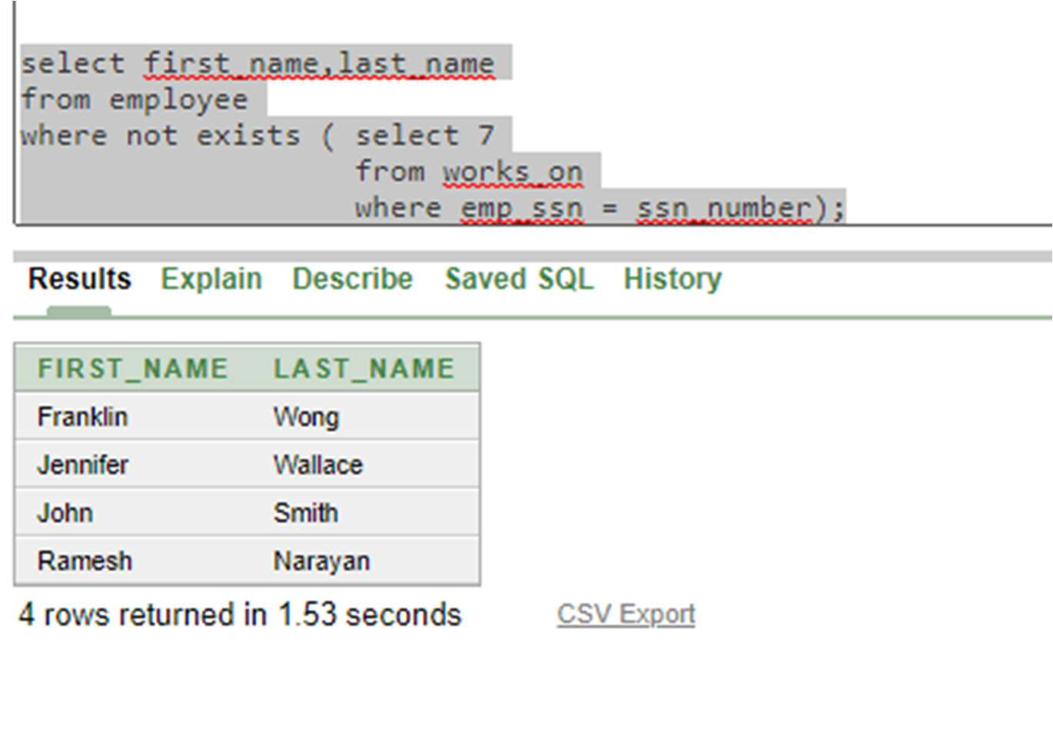

6.List the names of all managers who have no dependents. 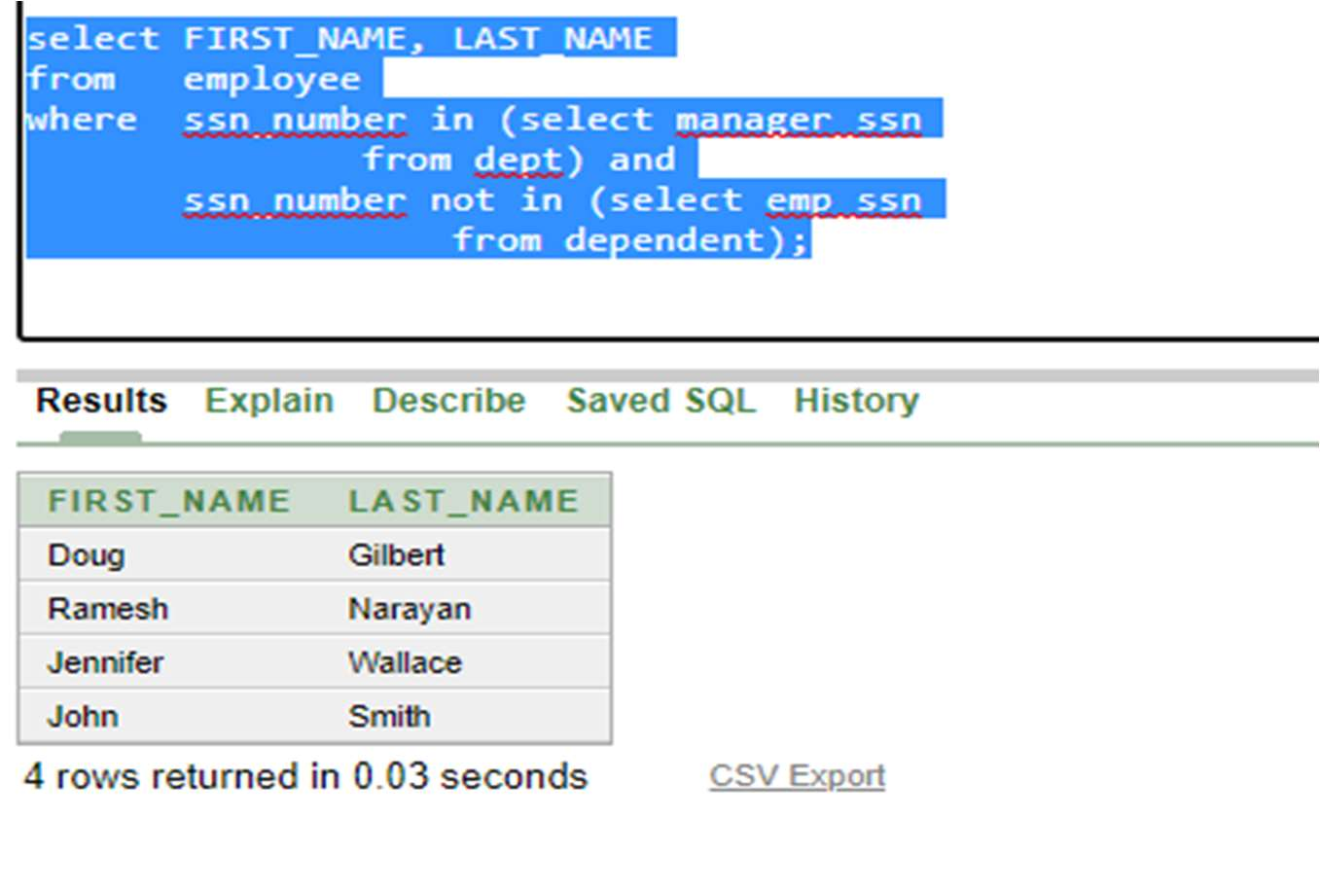

1. List the employee’s names and the department names if they happen to manage a department 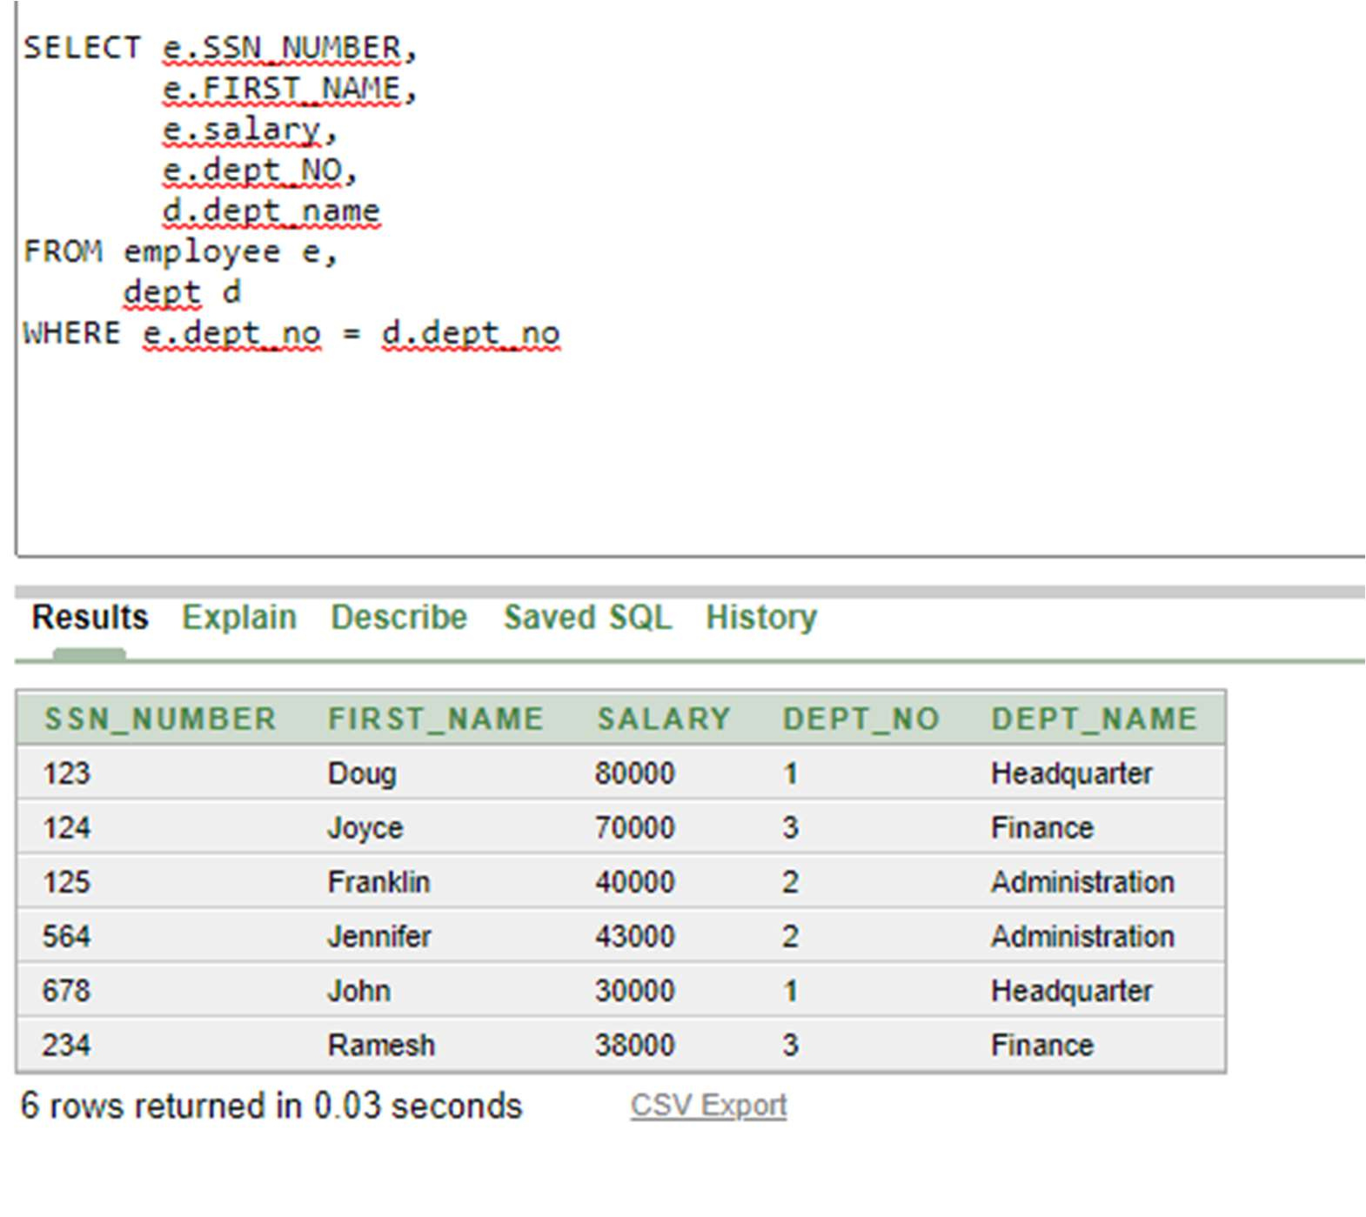
2. For each project retrieve the project number, project name and the number of employees who work on that project. 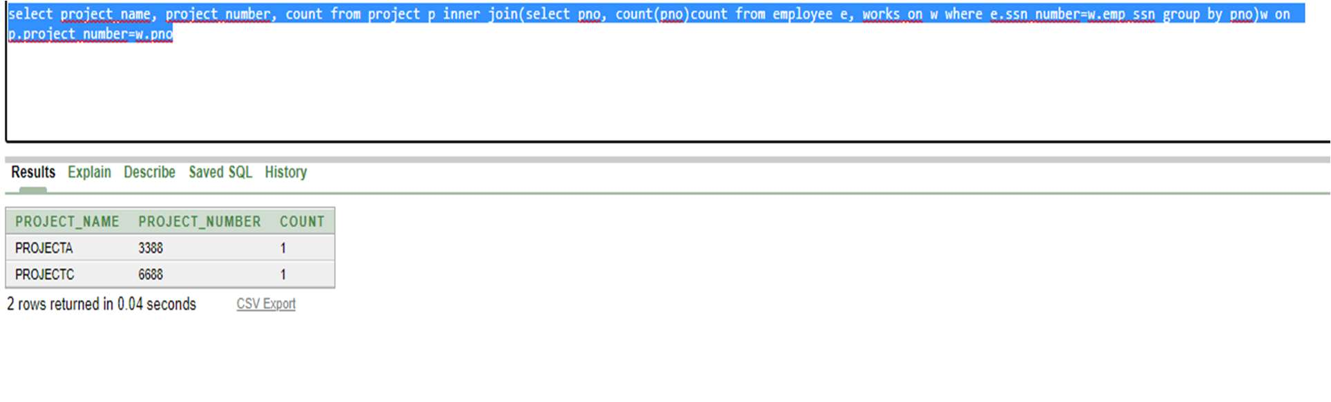
3. For each project, list the project name and the total hours per week (by all employees) spent on that project. 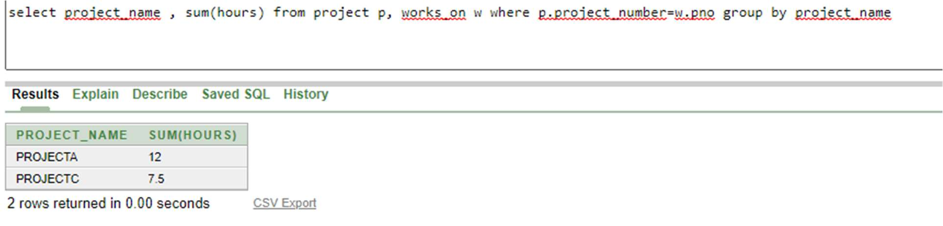

10.Retrieve the names of the employees who have 2 or more dependents.

